Numerical Solutions of

Ordinary Differential Equations

BAE Missile Freight Service

Author: Team MCCCXXXVII

Team: MCCCXXXVII

Team Leader: Carolyn Andrews

Team Members:

Carlos Lazo

Carolyn Andrews

Colin Fischer

Michael Doran

Course: Numerical Solutions of Ordinary Differential Equations

Instructor: Michael Richman

Group Hours: 35 hours

Date Submitted: 09/23/2008

Executive Summary

Problem

At BAE Systems, we are always looking for game changing ideas to bring to the marketplace. Recent studies in Business Development (BD) have shown that there is room for optimization in the freight delivery marketplace. Researchers in Advanced Systems and Technology (AS&T) and in the Leveraging Technology Innovation Organization (LTIO) determined that the most efficient way to optimize freight delivery is to utilize current missile technology.

With the declining defense market, there is a surplus of Trident missiles in the United States weapons stockpile, which BAE purchased as a very low price. Our team, MCCCXXXVII, was asked to find a way to use these Trident Missiles for freight transport. Our customer, Suburban AeroNautical Transportation Association (SANTA), has offered us a bonus if we deliver a working model in time for the busy Christmas season. We will receive an additional bonus if we are able to prove to the customer that our launch trajectory minimizes fuel consumption while maximizing performance. There will be one site on each coast; New York City on the east coast and Los Angeles on the west coast.

Method of Analysis

Our group used a fourth-order Runge-Kutta (R-K) differential equation model for all parts of the analysis, using a “building block” approach for solving the problem and MATLAB 7.6.0 as our primary development environment. We started with assumptions that were reasonable for ease of calculation. This allowed us to check that our programs were functioning correctly as solutions were derived.

In the first analysis step, our group assumed a flat earth with no rotation and constant gravity, no aerodynamic effects, and an instantaneous missile velocity. In the second analysis step, we changed our assumptions to take into account the curvature of the earth. We also defined gravity as constant and perpendicular to the surface of the earth. In the third analysis step, gravity was different at each time step, varying based on the distance from the center of the earth to the missile. In the last analysis step, we no longer assumed an instantaneous velocity. Instead, we gave the missile a constant thrust for a specified amount of time. Upon completing all steps, we went back and optimized the trajectories for all steps of the missile freight analysis.

Results / Recommendations

Given our assumptions and our optimized calculation for the final step of the analysis, we recommend using a modified Trident missile with an initial thrust period of 180.11 s at 33.33m/s², launching at an angle of 39°. Based on our optimization technique, a 39° launch constitutes the minimum thrust time for the missile, minimizing fuel consumption. The missile should also be launched with the initial bearings listed in the Assumptions section. In following our recommendations, SANTA will be able to deliver presents for the children of Los Angeles in 17.8 minutes.

Table of Contents

Executive Summary 2
Problem 2
Method of Analysis 2
Results / Recommendations 2
Problem Statement 5
Overview 5
System Description 5
Assumptions 6
System Analysis 7
Approach 7
Detailed Analysis 8
Analysis Step # 1 – Flat Earth 8
Analysis Step # 2 – Curved Earth 9
Analysis Step # 3 – Changing Magnitude of Gravity 10
Analysis Step # 4 – Adding Missile Thrust 10
MATLAB Optimization 11
Results 12
Results 12
Flat Earth 12
Curved Earth 13
Change Magnitude of Gravity 13
Recommendations 14
References 15
Appendix 16
Appendix A – Code 16
missilefreight1.m 16
findNextStepOne.m 19
missilefreight2.m 20
findNextStepTwo.m 23
missilefreight3.m 25
findNextStepThree.m 28
missilefreight4.m 30
findNextStepFourThrust.m 34
MissileComp.m 36
Appendix B - Equations 40
R-K Equations – Step # 1 Analysis 40
R-K Equations – Step # 2 Analysis 41
R-K Equations – Step # 3 Analysis 43
R-K Equations – Step # 4 Analysis 46
Appendix C - Graphs 49
Missile Trajectory for Analysis Step # 1 49
Missile Trajectory for Analysis Step # 2 49
Missiles 1 & 2 in Analysis Step # 2 Environment 50
Missile Trajectory for Analysis Step # 3 50
Missiles 1, 2, & 3 in Analysis Step # 3 Environment 51
Missile Trajectory for Analysis Step # 4 51

List of Figures

Figure (1): Flat Earth Coordinate Frame 7
Figure (2): Curved Earth Coordinate Frame 7
Figure (3): Geometry to Determine Trajectory Coordinates 9
Figure (4): Missile Trajectory for Analysis Step # 1 12
Figure (5): Missiles 1 & 2 in Analysis Step # 2 Environment 13
Figure (6): Missiles 1, 2, & 3 in Analysis Step # 3 Environment 14
Figure (7): Missile Trajectory for Analysis Step # 4 14

List of Tables

Table (1): Results Table 12

Nomenclature

Symbol | Definition | Units
v | Velocity | m/s
m | Mass | Kg (kilogram)
r | Radius | m
g | Gravity | m/s²
G | Gravitational Constant | m³/(kg*s²)
x | Distance (horizontal direction) | m
y | Distance (vertical direction) | m
θ | Initial missile launch angle (See Figure (3)) | Degrees
β | Angle of depression from JFK to LAX (See Figure (3)) | Degrees
Φ | Angle from center of the earth to missile (See Figure (3)) | Degrees
s | Arc Length | m
t | Time | Seconds
h | Time Step | Seconds
v’ | Acceleration | m/s²

Problem Statement

Overview

BAE Systems has decided to explore the commercial missile freight industry. The mentality of the American population is moving towards instant gratification. Currently, transporting freight from coast to coast is slow, taking days using ship, rail, or truck. Transportation by air costs more because of crew and maintenance expenses. Because the US Government is willing to sell us their surplus of Trident missiles, we believe BAE will be able to provide a cost effective alternative to the current methods of transportation. In addition, using a missile will reduce the transportation time from 6 or more hours to approximately 18 minutes.

Before we can commit to our customer, we must model and analyze the feasibility of this project. Since New York City and Los Angeles each represent a large market on their respective coasts, we will simulate our concept by flying a missile between these two cities. Our customer, SANTA, has requested we keep costs low so they can continue to provide high quality products to children worldwide. They also requested we maximize performance through fuel reduction so they can eventually expand their program to make deliveries worldwide in one night.

System Description

Our system consists of a modified Trident missile and a Federal Express (FedEx) truck. The FedEx truck drives into the cargo area of the missile for easy loading and unloading of payload. With a typical payload, the missile plus cargo totals about 40,000 kg. We have built launch and landing sites at John F. Kennedy International Airport (JFK) in New York City, NY and Los Angeles International Airport (LAX) in Los Angeles, CA. We hired a subcontractor to build a landing pad that will allow the missile to land safely without having to decelerate on descent.

The goal is to start with the simplest situation and slowly step up to the more complicated yet more realistic situation. In the first part of the analysis, our system assumes the earth is flat, has negligible aerodynamic effects, and maintains a constant gravitational force. The missile also has an initial velocity at launch. The missile system is modeled as a particle traveling through two-dimensional space with gravity acting in the negative Y direction in MATLAB.

In the second step of the analysis, the earth is a curved body while maintaining all other previous assumptions. This missile system is modeled as a two-dimensional particle with gravity now acting in both the X and Y directions. With this new model, calculations in reference to the center of the earth are used to calculate the vector components of gravity.

The third step brings in a varying gravitational force based on the distance from the missile to the center of the earth at any given time while maintaining all other previous assumptions. With a gravitational force changing based on radial distance, we recalculate gravity at each time step before splitting it into its respective X and Y components.

In the final step of the analysis, the missile’s initial velocity is replaced with a constant thrust. This new missile system is modeled across two stages. The first stage applies our constant thrust until a specific cutoff time. Once the missile reaches the cutoff time, the thrust is turned off and the missile falls into the ballistic stage, where only gravity acts upon it. In all situations, we try to find the launch angle that optimizes the lowest launch velocity as well as the time of flight.

Launching from JFK, we aim our missile towards 273°52′30″. When launching from LAX, we aim our missile in the direction of 066°03′14″. Through a series of analyses involving changes in the earth’s geometry, gravitational effects, and initial thrust with a given cutoff time, we choose a launch angle that minimizes fuel consumption. The missile takes advantage of both its thrust capability and the earth’s gravitational force to reach LAX safely within an acceptable distance.

Assumptions

See References section for numerical assumption verification.

- Distance from New York John F. Kennedy International Airport (JFK) to Los Angeles International Airport (LAX) is 3971530 m.
- These statistics were found on the Air Routing International website.
- We assume that there is no elevation difference between LA and NY.
- Weight of the missile plus the cargo is estimated to be 40,000Kg.
- The weight of a Trident missile is 33142Kg
- The weight of a FedEx truck is 14140 lbs which is 6413.79611Kg
- We added these 2 values together and rounded to account for actual cargo that will be transported in the truck.
- We assume the flight path of the missile is not obscured by mountains, buildings, satellites in space, or any other objects.
- We assume that the gravitational pull of the moon or other satellites in space is negligible.
- We assume that a team of engineers has developed a system for safely landing our missile without the need for us to decelerate prior to impact.
- The missile will be launched with an initial directional bearing of:
- 273°52′30″ for travel from JFK to LAX
- 066°03′14″ for travel from LAX to JFK
- Due to time constraints, our optimization method will iterate through 1 degree increments in order to search for the minimum necessary velocity.
- Our rocket thrust is assumed to be 33.3 m/s² for Step 4 of the analysis. This is based on the average acceleration of a trident missile over a 2 minute time period. Thus, the thrust is constant in both magnitude and direction.
- We assume the radius of the earth is 6,387,100m.
- We assume the earth’s gravitational constant is 6.67429 x 10⁻¹¹ m³/(kg*s²).

System Analysis

Approach

The missile freight service analysis was broken up into four distinct steps. Making geographical assumptions, our group approached each simulation given respective constraints.

The first step of our analysis assumed a flat earth. Using equations of particle motion and knowing that gravity only acted in the negative vertical direction, we performed hand calculations to derive the angle that minimized initial launch velocity. A Runge-Kutta (R-K) analysis in MATLAB using optimization confirmed our analytical, hand-calculated results. We used a regular coordinate system for these calculations.

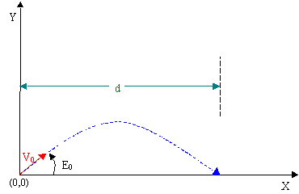
Figure (1): Flat Earth Coordinate Frame

The second and all subsequent parts assumed the earth was curved. We changed our R-K equations to account for the new curvature and gravity now being constant and perpendicular to the surface of the earth. MATLAB was used to find the angle that minimized initial launch velocity given the new geometry and gravitational constraints. Figure (2) shows the coordinate system and angles our group referenced to solve Analysis Steps # 2 – 4.

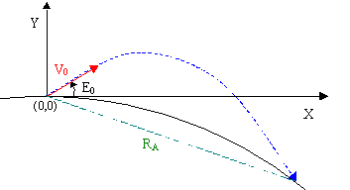
Figure (2): Curved Earth Coordinate Frame

The third part was nearly identical to our second step, except that gravity varied inversely with the square of the distance from the center of the earth. Gravity was recalculated at each R-K step using the new mathematical relationship, and MATLAB optimization was used to find the initial angle that minimized initial launch velocity.

The final part of the missile freight problem had the same gravitational model as part three. However, instead of an instantaneous velocity, a constant thrust was applied for a specific amount of time and then terminated. Using MATLAB, the optimal thrust time and resulting ballistic missile trajectory that would ensure a landing in Los Angeles was calculated using an iterative R-K analysis.

Detailed Analysis

Analysis Step # 1 – Flat Earth

For this step of the analysis, we assumed the earth is flat and does not rotate. Gravity was constant and aerodynamic effects were neglected. It was assumed that our thrust is instantaneously applied at launch, modeled as a constant initial velocity.

We used particle motion equations for constant acceleration in the Y direction. Since the earth was assumed flat, gravity acted in the negative Y direction for the missile’s complete flight:

Position: 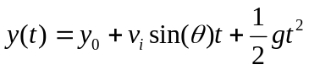 Equation (1)
Velocity: 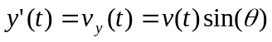 Equation (2)
Acceleration: 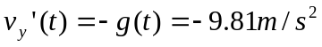 Equation (3)

Due to a lack of acceleration in the X direction, the X component of velocity was constant during the trajectory.

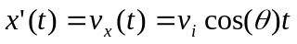 Equation (4) Equation (5)

Knowing the horizontal distance between JFK and LAX, we analytically solved for the velocity needed to reach our destination given any launch angle. Assuming our initial launch angle at 45°, we calculated the needed missile velocity. In solving for the launch velocities for angles around 45°, we found our initial guess to be the optimal solution.

Our group then used Equations (1) – (4) to develop the Runge-Kutta (R-K) 4th order differential equations. Performing an optimized, iterative R-K analysis in MATLAB between 40-50° with a step size of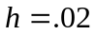, we determined the angle required to minimize initial launch velocity along with the time of flight. The angle and velocity determined through our MATLAB simulation matched the result found through our analytical approach. Equations for this step can be found under the Equation Appendix in the R-K Equations – Step # 1 Analysis subsection.

Analysis Step # 2 – Curved Earth

The second step of the analysis assumed that the earth was curved. Given this new geometry, our group used a Cartesian coordinate system centered about JFK for all future calculations.

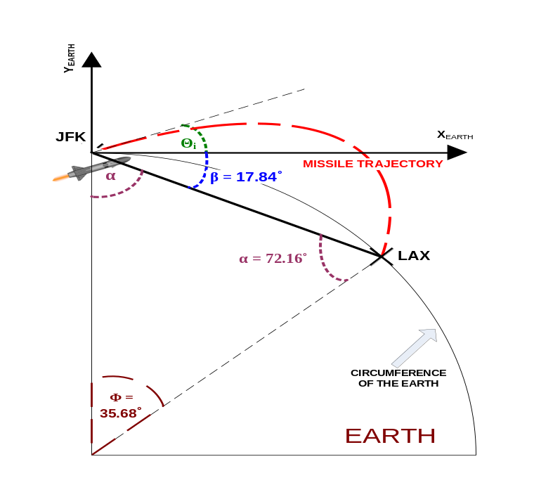
Figure (3): Geometry to Determine Trajectory Coordinates

In this step, gravity acted perpendicular to the surface of the earth at any given time. This meant that at each step of the missile trajectory, the constant gravity vector would need to be split into X and Y components based on, the angle between the center of the earth and our missile as seen in Figure (3). The gravity components affected the respective velocities.

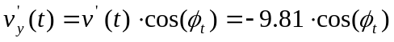 Equation (6)
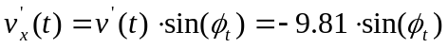 Equation (7)

By factoring in the change of gravity at each step to account for the curved earth, we developed an R-K analysis of the system in MATLAB based on the system developed in Analysis Step #1. We scanned through all interior angles between 25°-34° with an R-K step size of to find the angle that minimized initial launch velocity, as well as recorded the respective time of flight. Equations for this step can be found under the Equation Appendix in the R-K Equations – Step # 2 Analysis subsection.

Analysis Step # 3 – Changing Magnitude of Gravity

In Analysis Step # 3, gravity was not constant. Instead, it varied inversely with the square of the distance from the center of the earth and acted perpendicular to the surface of the earth. The earth remained curved, and aerodynamic effects were still neglected. Given this change, our group recalculated gravity at each time step in the missile simulation before splitting the vector into its X and Y components as seen in Equations (6) and (7).

Using the Universal Law of Gravitation and the known gravitational constant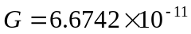 m³/(kg*s²), we derived a mathematical equation to find the gravity of the earth at a specific point in the trajectory. We calculated the distance from the center of the earth to the missile for each step, and then found the respective gravity at that point in time.

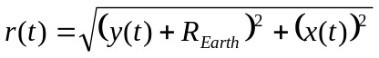 Equation (8)

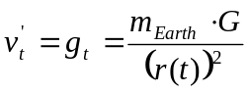 Equation (9)

After calculating the gravity based on missile position, the R-K analysis became almost identical to that of Analysis Step # 2. We chose an angle range between 30°-40° an R-K step size of to find the angle that minimized initial launch velocity, and recorded the respective time of flight. Equations for this step can be found under the Equation Appendix in the R-K Equations – Step # 3 Analysis subsection.

Analysis Step # 4 – Adding Missile Thrust

The fourth and final step of the analysis closely resembled that of Analysis Step # 3. The earth remained curved, aerodynamic effects were neglected, and gravity varied inversely with the square of the distance from the center of the earth and acted perpendicular to the surface of the earth. Instead of assuming an initial missile velocity, a thrust was applied in both constant magnitude and direction. The thrust was halted at a given cutoff time, causing the missile to fall into a ballistic mode where gravity was assumed to be the only acting force bringing it to our destination of LAX. We chose our thrust to be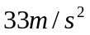, based on an actual Trident missile data.

This analysis was modeled as two sets of R-K equations in MATLAB. Assuming an initial thrust time and corrective step size, we applied thrust to the missile for that time period. Upon completion of this stage, we used the R-K equations from Analysis Step # 3 to model the trajectory given the position of the missile at the end of its thrust period. Based on ballistic trajectory overshoots or undershoots, the thrust was increased or decreased using the corrective thrust step until our missile hit LAX given the specified angle. Performing an optimized, iterative R-K analysis in MATLAB between 20-40° with a step size of, we determined the angle required to minimize the cutoff velocity, the time of flight, and the optimal thrust cutoff time. Equations used for this step can be found under the Equation Appendix in the R-K Equations – Step # 4 Analysis subsection.

MATLAB Optimization

MATLAB was the software package our group used to develop and solve the Runge-Kutta (R-K) equations for each analysis. Each step asked for us to optimize our solution.

For Analysis Steps # 1-3, this involved picking the angle that minimized the initial launch velocity. Assuming an initial angle within a chosen range, a starting guess velocity, and a corrective velocity step size, an iterative R-K equation was used to calculate the missile trajectory. The simulation was run until the simulated missile either landed or launched into orbit. We then checked to see if it was within a specific horizontal range of LAX. If the missile undershot LAX, we added our corrective step value to the initial missile velocity and ran the simulation again. If the missile overshot, we instead subtracted the corrective step. If the missile undershot on one iteration and overshot after being corrected (or vice versa), the corrective step was reduced and applied, so that we could quickly converge on the correct initial velocity. This helped increase velocity accuracy and minimized the search time for the optimal solution. The analysis was done for all angles within our specified range. In keeping track of the angle that minimized the initial launch velocity, we found our optimal solution.

The approach was similar for Analysis Step # 4. Based on undershoot or overshoot conditions, the thrust time was increased or decreased using a decreasing corrective thrust time step size.

In order to derive an accurate angular range for each model, our group started by iterating over a large range of angles, about 15-75°. We set the landing tolerance for a missile hit very high, allowing us to find a rough estimate of the needed initial angle. We then honed the angular range and reduced the dimensional landing tolerance to the numbers seen in the MATLAB code and in the results section. This provided further time optimization and increased missile accuracy.

All commented MATLAB code used for all analyses can be found in the Appendix A.

Results

Results

Model Characteristics | Launch Requirements
Model Characteristics | Elevation Angle | Cutoff Velocity | Time of Flight | Cutoff Time
Step #1 - Flat Earth | 45° | 6241.9 m/s | 899.84 s | N/A
Step #2 - Curved Earth | 30° | 5840.4 m/s | 896.28 s | N/A
Step #3 –  Change Magnitude of Gravity | 36° | 5414.6 m/s | 1065.9 s | N/A
Step #4 - Adding Missile Thrust | 39° | 5056.3 m/s | 1068.1 s | 180.11 s
Table (1): Results Table

All graphs can be found in Appendix C.

Flat Earth

With a flat earth, our miss distance after optimization was 77.01m in the X direction and 15.76m in the Y direction. This represents a miss percentage of .0019% in the X direction and .0016% in the Y direction. Our initial requirements were calculated by hand and were 6241.9 m/s. This was the same as our optimized calculations. There was no increase in accuracy between the initial requirements and final optimized results. Figure (4) represents our optimized solution with the origin representing New York and the red X representing Los Angeles.

0
0.5
1
1.5
2
2.5
3
3.5
4
4.5
x 10
6
-2
0
2
4
6
8
10
x 10
5
Distance in the x direction (m)
Distance in the y direction (m)
Missile Trajectory

Earth's Crust
Missile Trajectory
Los Angeles
Figure (4): Missile Trajectory for Analysis Step # 1

Curved Earth

In our next step, we assumed that earth to be round. This added some complication since we needed to account for gravity in both the X and Y directions. With a curved earth, our miss distance after optimization was 34.6m in the X direction and 70.2m in the Y direction. This represents a miss percentage of .0009% in the X direction and .0596% in the Y direction. The graph of the optimized solution, Missile Trajectory for Analysis Step 2, can be found in Appendix C. It represents our optimized solution, with the origin representing New York and the red X representing Los Angeles.

With a round earth, our equation for a flat earth caused our missile to land 1445.2m short of Los Angeles in the X direction and 1034.8m long in the Y direction. It was clear that we needed to edit our equations to take into account the fact that the earth was now round. A comparison of missile’s 1 and 2 in Analysis # 2’s environment can be seen in Figure (5).

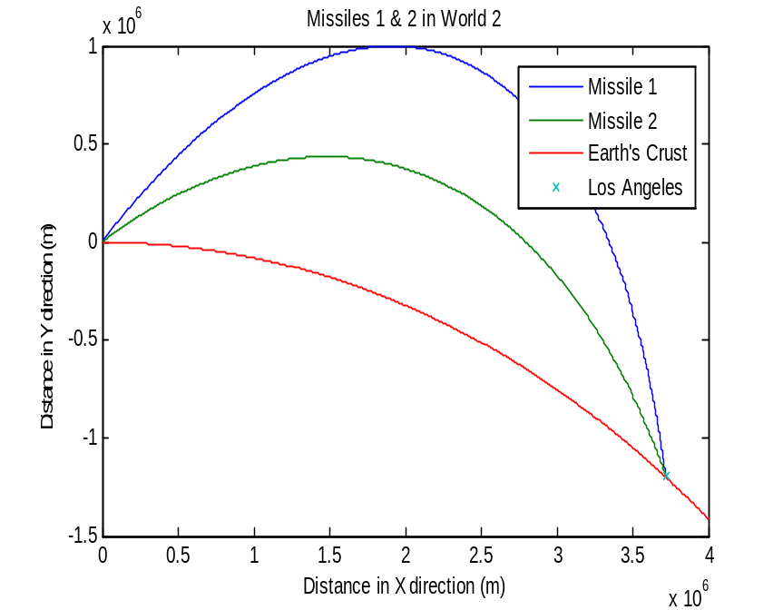
Figure (5): Missiles 1 & 2 in Analysis Step # 2 Environment

Change Magnitude of Gravity

Next, we assumed there to be a change in the magnitude of gravity based on how far away the missile was from the center of the earth. This added some complication because gravity changed per time step. With this dynamic magnitude change, our miss distance after optimization was 160.23m in the X direction and 112.21m in the Y direction. This represents a miss percentage of .0040% in the X direction and .0094% in the Y direction. The graph of the optimized solution, Missile Trajectory for Analysis Step 3, can be found in Appendix C.

With a round earth and varying gravity, our equation for a flat earth caused our missile to land 1,073,000m past Los Angeles in the X direction and 972,910m short in the Y direction. Our equation for a round earth with constant gravity caused our missile to land 678,770m past Los Angeles in the X direction and 562,340m long in the Y direction. It was clear that we needed to edit our equations to take into account the fact that the earth’s gravity was time dependant, based on missile distance. A comparison of missile’s 1 and 2 in world 2 can be seen in Figure (6).

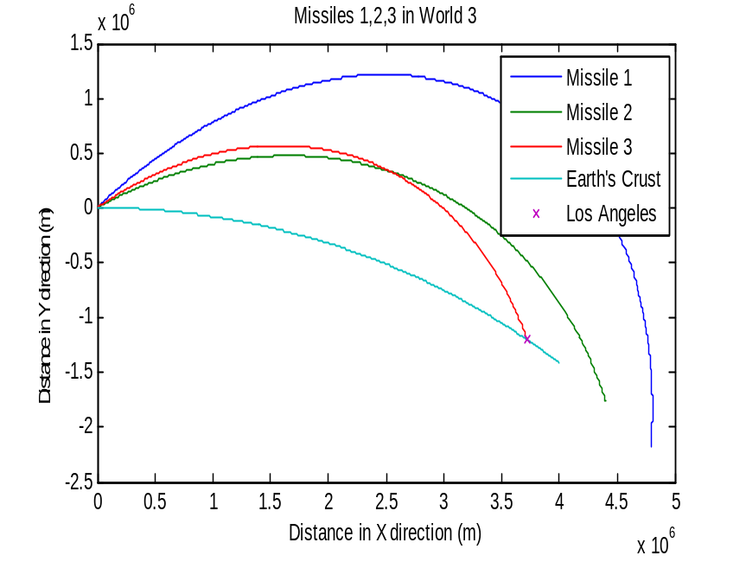
Figure (6): Missiles 1, 2, & 3 in Analysis Step # 3 Environment

Adding Missile Thrust

In adding missile thrust, our miss distance after optimization was 160.23m in the X direction and 112.21m in the Y direction. This represents a miss percentage of .0040% in the X direction and .0094% in the Y direction. In this case, without an instantaneous velocity, we chose 33.3m/s² as our thrust. This was based off thrust for a Trident missile. Figure (7) represents our optimized solution, minimizing fuel consumption by choosing the trajectory that minimizes thrust cutoff time to 180.11s with a launch angle of 39°.

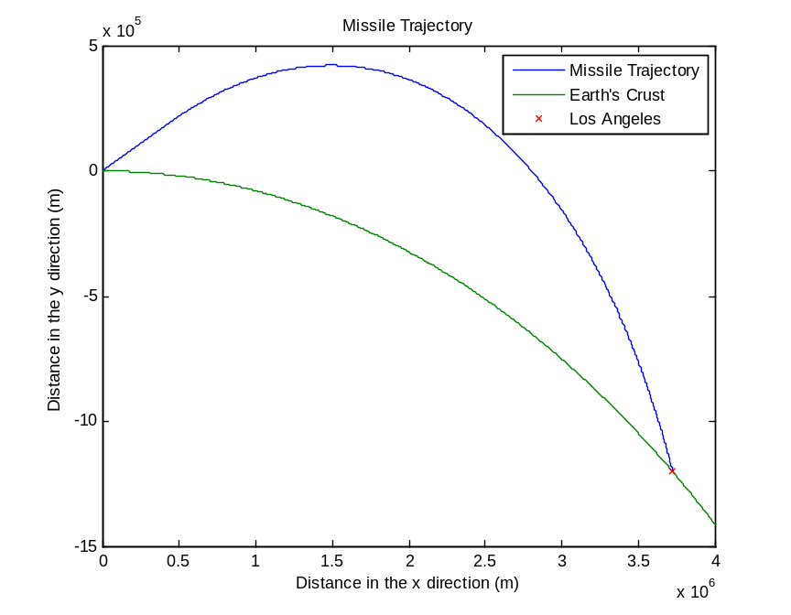
Figure (7): Missile Trajectory for Analysis Step # 4

Recommendations

Given our assumptions and our optimized calculation for the final step of the analysis, we recommend using a Trident missile with an initial thrust period of 180.11 seconds at 33.3 m/s², launched at an angle of 39°. The missile should be launched with the initial bearings listed in Assumption 7. In following our recommendations, SANTA will be able to deliver presents in a cost-effective manner for the children of Los Angeles in 17.8 minutes. Using traditional methods, the best case scenario would have taken six or more hours for delivery. This is a significant reduction in delivery time in comparison to freight delivery methods present in the world today.

References

1. http://www.airrouting.com/content/TimeDistanceForm.aspx
2. http://www.navy.mil/navydata/fact_display.asp?cid=2200&tid=1400&ct=2
3. http://www.uship.com/shipment/FED-EX-TRUCK/640555801/
4. http://www.ig.utexas.edu/outreach/googleearth/latlong.html
5. http://www.bookrags.com/wiki/Trident_missile

Appendix

Appendix A – Code

missilefreight1.m

% Clear working environment
clear all;
close all;

% Position of NY
yi = 0;
xi = 0;

% Position of LA
yLA = 0;
xLA = 3971530;

% Guess for initial velocity
vi = 6000;

% Hit Threshold
Th = 100;

% Loop control variables
hit = false;
last = 'X';

% Velocity initial step size
step = 1000;

% Placeholders for optimal answers
minV = 1000000000;
minAngle = 0;

%OPTIMUM SOLUTION SEARCH
% For all integer angles between 40 and 50
for angle = 40:50
% If LA has not been hit
while ~hit

% Calculate initial x and y velocities from angle
theta = angle*pi/180;
vyi = vi*sin(theta);
vxi = vi*cos(theta);

% Store them in working variables
y=yi;
vy=vyi;
x=xi;
vx=vxi;

% R-K step size
h=.02;

% Loop R-K until missile hits the ground (y=0)
while y>=yLA
[y,x,vy,vx]=findNextStepOne(h,x,y,vy,vx);
end

% If result is a hit
if xLA-Th<x && x<xLA+Th
% If initial velocity lower than stored, store it and angle
if vi<minV
minV=vi
minAngle = angle
end

% Set hit so we can move to the next angle
hit = true;

% Reset last for overshoot/undershoot
last = 'H';

% If result is undershoot
elseif xLA-Th>=x
% If last result was overshoot, we skipped over the city
if last == 'O'
step = step/5; % Reduce step size
end

% Set last to undershoot
last = 'U';

% Increase velocity
vi = vi+step;

% If result is overshoot
else
% If last result was underhoot, we skipped over the city
if last == 'U'
step = step/5; % Reduce step size
end

% Set last to overshoot
last = 'O';

% Decrease velocity
vi = vi-step;
end
end

% Reset hit
hit = false;
end

%NOW WE'RE GOING TO PLOT OPTIMAL SOLUTION!

% Get initial velocities from stored optimal theta and V
theta = minAngle*pi/180;
vyi = minV*sin(theta);
vxi = minV*cos(theta);

% Put it in working variables
y=yi;
vy=vyi;
vx=vxi;
x=xi;

% R-K step size
h=.02;

% Initialize some arrays to store flight data
yf = [];
vyf = [];
xf = [];

% While the missile is in the air (y>0)
while y>=yLA
% Loop R-K, Store flight info
[y,x,vy,vx]=findNextStepOne(h,x,y,vy,vx);
yf=[yf y];
vyf=[vyf vy];
xf=[xf x];
end

% Plot trajectory, Ground, and LA
plot(0:4499999,zeros(1,4500000),[xi xf],[yi yf],xLA,0,'X');

findNextStepOne.m

function [y,x,vy,vx]=findNextStepOne(h,xi,yi,vyi,vxi)
% Takes step size, initial x and y positions, and initial x and y
% velocities. Calculates new x and y positions and velocities

g = -9.81; % Acceleration due to gravity - Constant

% Determine 1st set of K values
ky1 = h*vyi;
kx1 = h*vxi;
kvy1 = h*g;

% Determine 1st midpoint estimate values
ym1 = yi+0.5*ky1;
xm1 = xi+0.5*kx1;
vym1 = vyi+0.5*kvy1;

% Determine 2nd set of K values
ky2 = h*vym1;
kx2 = h*vxi;
kvy2 = h*g;

% Determine 2nd midpoint estimate values
ym2 = yi+0.5*ky2;
xm2 = xi+0.5*kx2;
vym2 = vyi+0.5*kvy2;

% Determine 3rd set of K values
ky3 = h*vym2;
kx3 = h*vxi;
kvy3 = h*g;

% Determine 3rd midpoint estimate values
ym3 = yi+0.5*ky3;
xm3 = xi+0.5*kx3;
vym3 = vyi+0.5*kvy3;

% Determine 4th set of K values
ky4 = h*vym3;
kx4 = h*vxi;
kvy4 = h*g;

% Determine 4th point estimate values
ym4 = yi+ky4;
xm4 = xi+kx4;
vym4 = vyi+kvy4;

% Solve for next point
y = yi+1/6*(ky1+2*ky2+2*ky3+ky4);
vy = vyi+1/6*(kvy1+2*kvy2+2*kvy3+kvy4);
x = xi+1/6*(kx1+2*kx2+2*kx3+kx4);
vx = vxi;

missilefreight2.m

% Clear working environment
clear all;
close all;

% Position of NY
xi = 0;
yi = 0;

% Radius of the Earth
Re = 6378100;

% Position of LA
xLA = 3719800;
yLA = 5181040-Re;

% Guess initial velocity
vi = 6100;

% Loop control variables
hit = false;
last = 'X';

% Hit Threshold
Th = 100;

% Velocity initial step size
step = 1000;

% Placeholders for optimal answers
minV = 10000000000;
minAngle = 0;

%OPTIMUM SOLUTION SEARCH
% For all integer angles between 25 and 34
for angle = 25:34
% If LA has not been hit
while ~hit;

% Calculate initial x and y velocities from angle
theta = angle*pi/180;
vyi = vi*sin(theta);
vxi = vi*cos(theta);

% Store them in working variables
y=yi;
x=xi;
vx=vxi;
vy=vyi;

% R-K Step size
h=.02;

% Loop R-K until missile hits the ground (y=circle eqn)
while y>=sqrt(-x^2+Re^2)-Re && x<Re
[x,y,vx,vy]=findNextStepTwo(h,x,y,vy,vx);
end

% If result is a hit
if xLA-Th<x && x<xLA+Th
% If initial velocity lower than stored, store it and angle
if vi<minV
minV=vi
minAngle = angle
end

% Set hit so we can move to the next angle
hit = true;

% Reset last for overshoot/undershoot
last = 'H';

% If result is undershoot
elseif xLA-Th>=x
% If last result was overshoot, we skipped over the city
if last == 'O'
step = step/5; % Reduce step size
end

% Set last to undershoot
last = 'U';

% Increase velocity
vi = vi+step;

% If result is overshoot
else
% If last result was underhoot, we skipped over the city
if last == 'U'
step = step/5; % Reduce step size
end

% Set last to overshoot
last = 'O';

% Decrease velocity
vi = vi-step;
end
end

% Reset hit
hit = false;
end

%NOW WE'RE GOING TO PLOT OPTIMAL SOLUTION!

% Get initial velocities from stored optimal theta and V
theta = minAngle*pi/180;
vyi = minV*sin(theta);
vxi = minV*cos(theta);

% Put it in working variables
y=yi;
x=xi;
vx=vxi;
vy=vyi;

% R-K step size
h=.02;

% Initialize some arrays to store flight data
yf = [];
xf = [];
vyf = [];
vxf = [];

% While the missile is in the air (y>Circle equation)
while y>=sqrt(-x^2+Re^2)-Re && x<Re
% Loop R-K, Store flight info
[x,y,vx,vy]=findNextStepTwo(h,x,y,vy,vx);
yf=[yf y];
xf=[xf x];
vyf=[vyf vy];
vxf=[vxf vx];
end

% Find an equation for the ground
worldx = 0:10:4000000;
worldy = sqrt(6378100^2-worldx.^2)-6378100;

% Plot trajectory, Ground, and LA
plot([xi xf],[yi yf],worldx,worldy,3719800,5181040-6378100,'X');

findNextStepTwo.m

function [x,y,vx,vy]=findNextStepTwo(h,xi,yi,vyi,vxi)
% Takes step size, initial x and y positions, and initial x and y
% velocities. Calculates new x and y positions and velocities

g = -9.81; % Acceleration due to gravity
re = 6378100; %radius of the earth;

% Initial Gravity Vectors
phii = atan(xi/(re+yi));
gyi = g*cos(phii);
gxi = g*sin(phii);

% Determine 1st set of K values
ky1 = h*vyi;
kx1 = h*vxi;
kvy1 = h*gyi;
kvx1 = h*gxi;

% Determine 1st midpoint estimate values
ym1 = yi+0.5*ky1;
xm1 = xi+0.5*kx1;
vym1 = vyi+0.5*kvy1;
vxm1 = vxi+0.5*kvx1;

% New Gravity Vectors
phi1 = atan(xm1/(re+ym1));
gym1 = g*cos(phi1);
gxm1 = g*sin(phi1);

% Determine 2nd set of K values
ky2 = h*vym1;
kx2 = h*vxm1;
kvy2 = h*gym1;
kvx2 = h*gxm1;

% Determine 2nd midpoint estimate values
ym2 = yi+0.5*ky2;
xm2 = xi+0.5*kx2;
vym2 = vyi+0.5*kvy2;
vxm2 = vxi+0.5*kvx2;

% 3rd Gravity Vectors
phi2 = atan(xm2/(re+ym2));
gym2 = g*cos(phi2);
gxm2 = g*sin(phi2);

% Determine 3rd set of K values
ky3 = h*vym2;
kx3 = h*vxm2;
kvy3 = h*gym2;
kvx3 = h*gxm2;

% Determine 3rd midpoint estimate values
ym3 = yi+0.5*ky3;
xm3 = xi+0.5*kx3;
vym3 = vyi+0.5*kvy3;
vxm3 = vxi+0.5*kvx3;

% 4th Gravity Vectors
phi3 = atan(xm3/(re+ym3));
gym3 = g*cos(phi3);
gxm3 = g*sin(phi3);

% Determine 4th set of K values
ky4 = h*vym3;
kx4 = h*vxm3;
kvy4 = h*gym3;
kvx4 = h*gxm3;

% Determine 4th point estimate values
ym4 = yi+ky4;
xm4 = xi+kx4;
vym4 = vyi+kvy4;
vxm4 = vxi+kvx4;

% Last gravity vectors
phi4 = atan(xm4/(re+ym4));
gym4 = g*cos(phi4);
gxm4 = g*sin(phi4);

% Solve for next point
y = yi+1/6*(ky1+2*ky2+2*ky3+ky4);
x = xi+1/6*(kx1+2*kx2+2*kx3+kx4);
vy = vyi+1/6*(kvy1+2*kvy2+2*kvy3+kvy4);
vx = vxi+1/6*(kvx1+2*kvx2+2*kvx3+kvx4);

missilefreight3.m

% Clear working environment
clear all;
close all;

% Position of NY
yi = 0;
xi = 0;

% Radius of the Earth
Re = 6378100;

% Position of LA
xLA = 3719800;
yLA = 5181040-Re;

% Guess initial velocity
vi = 6200;

% Loop control variables
hit = false;
last = 'X';

% Hit Threshold
Th = 100;

% Velocity initial step size
step = 1000;

% Placeholders for optimal answers
minV = 10000000000;
minAngle = 0;

%OPTIMUM SOLUTION SEARCH
% For all integer angles between 30 and 40
for angle = 30:40
% If LA has not been hit
while ~hit

% Calculate initial x and y velocities from angle
theta = angle*pi/180;
vyi = vi*sin(theta);
vxi = vi*cos(theta);

% Store them in working variables
y=yi;
x=xi;
vx=vxi;
vy=vyi;

% R-K Step size
h=.02;

% Loop R-K until missile hits the ground (y=circle eqn)
while y>=sqrt(-x^2+Re^2)-Re && x<Re
[x,y,vx,vy]=findNextStepThree(h,x,y,vy,vx);
end

% If result is a hit
if xLA-Th<x && x<xLA+Th
% If initial velocity lower than stored, store it and angle
if vi<minV
minV=vi
minAngle = angle
end

% Set hit so we can move to the next angle
hit = true;

% Reset last for overshoot/undershoot
last = 'H';

% Reset initial step
step = 1000;

% If result is undershoot
elseif xLA-Th>=x
% If last result was overshoot, we skipped over the city
if last == 'O'
step = step/5; % Reduce step size
end

% Set last to undershoot
last = 'U';

% Increase velocity
vi = vi+step;

% If result is overshoot
else
% If last result was underhoot, we skipped over the city
if last == 'U'
step = step/5; % Reduce step size
end

% Set last to overshoot
last = 'O';

% Decrease velocity
vi = vi-step;
end
end

% Reset hit
hit = false;
end

%NOW WE'RE GOING TO PLOT OPTIMAL SOLUTION!

% Get initial velocities from stored optimal theta and V
theta = minAngle*pi/180;
vyi = minV*sin(theta);
vxi = minV*cos(theta);

% Put it in working variables
y=yi;
x=xi;
vx=vxi;
vy=vyi;

% R-K step size
h=.02;

% Initialize some arrays to store flight data
yf = [];
xf = [];
vyf = [];
vxf = [];

% While the missile is in the air (y>Circle equation)
while y>=sqrt(-x^2+Re^2)-Re && x<Re
% Loop R-K, Store flight info
[x,y,vx,vy]=findNextStepThree(h,x,y,vy,vx);
yf=[yf y];
xf=[xf x];
vyf=[vyf vy];
vxf=[vxf vx];
end

% Find an equation for the ground
worldx = 0:10:4000000;
worldy = sqrt(Re^2-worldx.^2)-Re;

% Plot trajectory, Ground, and LA
plot([xi xf],[yi yf],worldx,worldy,xLA,yLA,'X');

findNextStepThree.m

function [x,y,vx,vy]=findNextStepThree(h,xi,yi,vyi,vxi)
% Takes step size, initial x and y positions, and initial x and y
% velocities. Calculates new x and y positions and velocities

m = 5.9736*10^24; % Mass of the Earth
G = -6.67428*10^-11; % Gravitational Constant
re = 6378100; % Radius of Earth

% Initial Gravity Magnitude and Vectors
phii = atan(xi/(re+yi));
ri = sqrt((yi+re)^2+xi^2);
gi = m*G/ri^2;
gyi = gi*cos(phii);
gxi = gi*sin(phii);

% Determine 1st set of K values
ky1 = h*vyi;
kx1 = h*vxi;
kvy1 = h*gyi;
kvx1 = h*gxi;

% Determine 1st midpoint estimate values
ym1 = yi+0.5*ky1;
xm1 = xi+0.5*kx1;
vym1 = vyi+0.5*kvy1;
vxm1 = vxi+0.5*kvx1;

% Next Gravity Magnitude and Vectors
phi1 = atan(xm1/(re+ym1));
r1 = sqrt((ym1+re)^2+xm1^2);
g1 = m*G/r1^2;
gym1 = g1*cos(phi1);
gxm1 = g1*sin(phi1);

% Determine 2nd set of K values
ky2 = h*vym1;
kx2 = h*vxm1;
kvy2 = h*gym1;
kvx2 = h*gxm1;

% Determine 2nd midpoint estimate values
ym2 = yi+0.5*ky2;
xm2 = xi+0.5*kx2;
vym2 = vyi+0.5*kvy2;
vxm2 = vxi+0.5*kvx2;

% 3rd Gravity Magnitude and Vectors
phi2 = atan(xm2/(re+ym2));
r2 = sqrt((ym2+re)^2+xm2^2);
g2 = m*G/r2^2;
gym2 = g2*cos(phi2);
gxm2 = g2*sin(phi2);

% Determine 3rd set of K values
ky3 = h*vym2;
kx3 = h*vxm2;
kvy3 = h*gym2;
kvx3 = h*gxm2;

% Determine 3rd midpoint estimate values
ym3 = yi+0.5*ky3;
xm3 = xi+0.5*kx3;
vym3 = vyi+0.5*kvy3;
vxm3 = vxi+0.5*kvx3;

% 4th Gravity Magnitude and Vectors
phi3 = atan(xm3/(re+ym3));
r3 = sqrt((ym3+re)^2+xm3^2);
g3 = m*G/r3^2;
gym3 = g3*cos(phi3);
gxm3 = g3*sin(phi3);

% Determine 4th set of K values
ky4 = h*vym3;
kx4 = h*vxm3;
kvy4 = h*gym3;
kvx4 = h*gxm3;

% Determine 4th point estimate values
ym4 = yi+ky4;
xm4 = xi+kx4;
vym4 = vyi+kvy4;
vxm4 = vxi+kvx4;

% Last Gravity Magnitude and Vectors
phi4 = atan(xm4/(re+ym4));
r4 = sqrt((ym4+re)^2+xm4^2);
g4 = m*G/r4^2;
gym4 = g4*cos(phi4);
gxm4 = g4*sin(phi4);

% Solve for next point
y = yi+1/6*(ky1+2*ky2+2*ky3+ky4);
x = xi+1/6*(kx1+2*kx2+2*kx3+kx4);
vy = vyi+1/6*(kvy1+2*kvy2+2*kvy3+kvy4);
vx = vxi+1/6*(kvx1+2*kvx2+2*kvx3+kvx4);

missilefreight4.m

% Clear working environment
clear all;
close all;

% Position of NY
yi = 0;
xi = 0;

% Radius of the Earth
Re = 6378100;

% Position of LA
xLA = 3719800;
yLA = 5181040-Re;

% Guess initial velocity
vi = 0;

% Loop control variables
hit = false;
last = 'X';

% Hit Threshold
Th = 1000;

% Thrust Time Initial Step Size
step = 100;

% Thrust Value and Initial Thrust Time
thrust = 33.3;
tThrust = 200;

% Placeholders for optimal answers
minT = 10000000000;
minAngle = 0;

%OPTIMUM SOLUTION SEARCH
% For all integer angles between 20 and 40
for angle = 20:40
% If LA has not been hit
while ~hit

% Calculate initial x and y velocities from angle
theta = angle*pi/180;
vyi = vi; % 0
vxi = vi; % 0

% Store them in working variables
y=yi;
x=xi;
vx=vxi;
vy=vyi;

% R-K Step size
h=.02;

% Calculate number of steps at h intervals to meet thrust time
nThrust = ceil(tThrust/h);

% Run R-K under Thrust conditions
for i=1:nThrust
[x,y,vx,vy]=findNextStepFourThrust(h,x,y,vy,vx,thrust,theta);
% If we hit the ground under thrust, STOP!
if y<sqrt(-x^2+Re^2)-Re
break;
end
end

% Loop R-K until missile hits the ground (y=circle eqn)
while y>=sqrt(-x^2+Re^2)-Re && x<Re
[x,y,vx,vy]=findNextStepThree(h,x,y,vy,vx);
end

% If result is a hit
dist = xLA-x
if xLA-Th<x && x<xLA+Th
% If thrust time is lower than stored, store it and angle
if tThrust<minT
minT=tThrust
minAngle = angle
end

% Set hit so we can move to the next angle
hit = true;

% Reset last for overshoot/undershoot
last = 'H';

step = 100;

% If result is undershoot
elseif xLA-Th>=x
% If last result was overshoot, we skipped over the city
if last == 'O'
step = step/2; % Reduce step size
end

% Set last to undershoot
last = 'U';

% Increase velocity
tThrust = tThrust+step;

% If result is overshoot
else
% If last result went to orbit, drastically reduce thrust time
if x>Re
tThrust = tThrust/2;
else

% If last result was underhoot, we skipped over the city
if last == 'U'
step = step/2; % Reduce step size
end

% Decrease velocity
tThrust = tThrust-step;
end

% Set last to overshoot
last = 'O';
end
end

% Reset hit
hit = false;
end

%NOW WE'RE GOING TO PLOT OPTIMAL SOLUTION!

% Get initial velocities from stored optimal theta and V
theta = minAngle*pi/180;
vyi = 0;
vxi = 0;

% Put it in working variables
y=yi;
x=xi;
vx=vxi;
vy=vyi;

% R-K step size
h=.02;

% Calculate number of steps at h intervals to meet thrust time
nThrust = ceil(minT/h);

% Initialize some arrays to store flight data
yf = [];
xf = [];
vyf = [];
vxf = [];

% Run R-K under Thrust conditions
for i=1:nThrust
[x,y,vx,vy]=findNextStepFourThrust(h,x,y,vy,vx,thrust,theta);
% If we hit the ground under thrust, STOP!
if y<sqrt(-x^2+Re^2)-Re
break;
end
yf=[yf y];
xf=[xf x];
vyf=[vyf vy];
vxf=[vxf vx];
end

% While the missile is in the air (y>Circle equation)
while y>=sqrt(-x^2+Re^2)-Re && x<Re
% Loop R-K, Store flight info
[x,y,vx,vy]=findNextStepThree(h,x,y,vy,vx);
yf=[yf y];
xf=[xf x];
vyf=[vyf vy];
vxf=[vxf vx];
end

% Find an equation for the ground
worldx = 0:10:4000000;
worldy = sqrt(6378100^2-worldx.^2)-6378100;

% Plot trajectory, Ground, and LA
plot([xi xf],[yi yf],worldx,worldy,3719800,5181040-6378100,'X');

findNextStepFourThrust.m

function [x,y,vx,vy]=findNextStepFourThrust(h,xi,yi,vyi,vxi,Th,theta)
% Takes step size, initial x and y positions, initial x and y
% velocities, and thrust magnitude and angle. Calculates new x and y
% positions and velocities

m = 5.9736*10^24; % Mass of the Earth
G = -6.67428*10^-11; % Gravitational Constant
re = 6378100; % Radius of Earth

% Initial Gravity Magnitude and Acceleration Vectors
phii = atan(xi/(re+yi));
ri = sqrt((yi+re)^2+xi^2);
gi = m*G/ri^2;
gyi = gi*cos(phii)+Th*sin(theta);
gxi = gi*sin(phii)+Th*cos(theta);

% Determine 1st set of K values
ky1 = h*vyi;
kx1 = h*vxi;
kvy1 = h*gyi;
kvx1 = h*gxi;

% Determine 1st midpoint estimate values
ym1 = yi+0.5*ky1;
xm1 = xi+0.5*kx1;
vym1 = vyi+0.5*kvy1;
vxm1 = vxi+0.5*kvx1;

% Next Gravity Magnitude and Acceleration Vectors
phi1 = atan(xm1/(re+ym1));
r1 = sqrt((ym1+re)^2+xm1^2);
g1 = m*G/r1^2;
gym1 = g1*cos(phi1)+Th*sin(theta);
gxm1 = g1*sin(phi1)+Th*cos(theta);

% Determine 2nd set of K values
ky2 = h*vym1;
kx2 = h*vxm1;
kvy2 = h*gym1;
kvx2 = h*gxm1;

% Determine 2nd midpoint estimate values
ym2 = yi+0.5*ky2;
xm2 = xi+0.5*kx2;
vym2 = vyi+0.5*kvy2;
vxm2 = vxi+0.5*kvx2;

% Next Gravity Magnitude and Acceleration Vectors
phi2 = atan(xm2/(re+ym2));
r2 = sqrt((ym2+re)^2+xm2^2);
g2 = m*G/r2^2;
gym2 = g2*cos(phi2)+Th*sin(theta);
gxm2 = g2*sin(phi2)+Th*cos(theta);

% Determine 3rd set of K values
ky3 = h*vym2;
kx3 = h*vxm2;
kvy3 = h*gym2;
kvx3 = h*gxm2;

% Determine 3rd midpoint estimate values
ym3 = yi+0.5*ky3;
xm3 = xi+0.5*kx3;
vym3 = vyi+0.5*kvy3;
vxm3 = vxi+0.5*kvx3;

% 4th Gravity Magnitude and Acceleration Vectors
phi3 = atan(xm3/(re+ym3));
r3 = sqrt((ym3+re)^2+xm3^2);
g3 = m*G/r3^2;
gym3 = g3*cos(phi3)+Th*sin(theta);
gxm3 = g3*sin(phi3)+Th*cos(theta);

% Determine 4th set of K values
ky4 = h*vym3;
kx4 = h*vxm3;
kvy4 = h*gym3;
kvx4 = h*gxm3;

% Determine 4th point estimate values
ym4 = yi+ky4;
xm4 = xi+kx4;
vym4 = vyi+kvy4;
vxm4 = vxi+kvx4;

% Last Gravity Magnitude and Acceleration Vectors
phi4 = atan(xm4/(re+ym4));
r4 = sqrt((ym4+re)^2+xm4^2);
g4 = m*G/r4^2;
gym4 = g4*cos(phi4)+Th*sin(theta);
gxm4 = g4*sin(phi4)+Th*cos(theta);

% Solve for next point
y = yi+1/6*(ky1+2*ky2+2*ky3+ky4);
x = xi+1/6*(kx1+2*kx2+2*kx3+kx4);
vy = vyi+1/6*(kvy1+2*kvy2+2*kvy3+kvy4);
vx = vxi+1/6*(kvx1+2*kvx2+2*kvx3+kvx4);

MissileComp.m

% Clear working environment
clear all;
close all;

% Position of NY
xi = 0;
yi = 0;

% Radius of the Earth
Re = 6378100;

% Position of LA
xLA = 3719800;
yLA = 5181040-Re;

%% Missiles 1,2 in Missile World 2

% MISSILE 1
minAngle = 45;
minV = 6241.9;
theta = minAngle*pi/180;
vyi = minV*sin(theta);
vxi = minV*cos(theta);

% Put it in working variables
y=yi;
x=xi;
vx=vxi;
vy=vyi;

% R-K step size
h=.02;

% Initialize some arrays to store flight data
yf1 = [];
xf1 = [];
vyf1 = [];
vxf1 = [];

% While the missile is in the air (y>Circle equation)
while y>=sqrt(-x^2+Re^2)-Re && x<Re
% Loop R-K, Store flight info
[x,y,vx,vy]=findNextStepTwo(h,x,y,vy,vx);
yf1=[yf1 y];
xf1=[xf1 x];
vyf1=[vyf1 vy];
vxf1=[vxf1 vx];
end
DIST1inWORLD2x = x-xLA
DIST1inWORLD2y = y-yLA

% MISSILE 2
minAngle = 30;
minV = 5840.4;
theta = minAngle*pi/180;
vyi = minV*sin(theta);
vxi = minV*cos(theta);

% Put it in working variables
y=yi;
x=xi;
vx=vxi;
vy=vyi;

% R-K step size
h=.02;

% Initialize some arrays to store flight data
yf2 = [];
xf2 = [];
vyf2 = [];
vxf2 = [];

% While the missile is in the air (y>Circle equation)
while y>=sqrt(-x^2+Re^2)-Re && x<Re
% Loop R-K, Store flight info
[x,y,vx,vy]=findNextStepTwo(h,x,y,vy,vx);
yf2=[yf2 y];
xf2=[xf2 x];
vyf2=[vyf2 vy];
vxf2=[vxf2 vx];
end

DIST2inWORLD2x = x-xLA
DIST2inWORLD2y = y-yLA

% Find an equation for the ground
worldx = 0:10:4000000;
worldy = sqrt(6378100^2-worldx.^2)-6378100;

% Plot trajectory, Ground, and LA
plot([xi xf1],[yi yf1],[xi xf2],[yi yf2],worldx,worldy,3719800,5181040-6378100,'X');

%% MISSILES 1,2,3 in MISSILE WORLD 3

% MISSILE 1
minAngle = 45;
minV = 6241.9;

% Get initial velocities from stored optimal theta and V
theta = minAngle*pi/180;
vyi = minV*sin(theta);
vxi = minV*cos(theta);

% Put it in working variables
y=yi;
x=xi;
vx=vxi;
vy=vyi;

% R-K step size
h=.02;

% Initialize some arrays to store flight data
yf1 = [];
xf1 = [];
vyf1 = [];
vxf1 = [];

% While the missile is in the air (y>Circle equation)
while y>=sqrt(-x^2+Re^2)-Re && x<Re
% Loop R-K, Store flight info
[x,y,vx,vy]=findNextStepThree(h,x,y,vy,vx);
yf1=[yf1 y];
xf1=[xf1 x];
vyf1=[vyf1 vy];
vxf1=[vxf1 vx];
end

DIST1inWORLD3x = x-xLA
DIST1inWORLD3y = y-yLA

% MISSILE 2
minAngle = 30;
minV = 5840.4;

% Get initial velocities from stored optimal theta and V
theta = minAngle*pi/180;
vyi = minV*sin(theta);
vxi = minV*cos(theta);

% Put it in working variables
y=yi;
x=xi;
vx=vxi;
vy=vyi;

% R-K step size
h=.02;

% Initialize some arrays to store flight data
yf2 = [];
xf2 = [];
vyf2 = [];
vxf2 = [];

% While the missile is in the air (y>Circle equation)
while y>=sqrt(-x^2+Re^2)-Re && x<Re
% Loop R-K, Store flight info
[x,y,vx,vy]=findNextStepThree(h,x,y,vy,vx);
yf2=[yf2 y];
xf2=[xf2 x];
vyf2=[vyf2 vy];
vxf2=[vxf2 vx];
end

DIST2inWORLD3x = x-xLA
DIST2inWORLD3y = y-yLA

% MISSILE 3
minAngle = 36;
minV = 5414.5;

% Get initial velocities from stored optimal theta and V
theta = minAngle*pi/180;
vyi = minV*sin(theta);
vxi = minV*cos(theta);

% Put it in working variables
y=yi;
x=xi;
vx=vxi;
vy=vyi;

% R-K step size
h=.02;

% Initialize some arrays to store flight data
yf3 = [];
xf3 = [];
vyf3 = [];
vxf3 = [];

% While the missile is in the air (y>Circle equation)
while y>=sqrt(-x^2+Re^2)-Re && x<Re
% Loop R-K, Store flight info
[x,y,vx,vy]=findNextStepThree(h,x,y,vy,vx);
yf3=[yf3 y];
xf3=[xf3 x];
vyf3=[vyf3 vy];
vxf3=[vxf3 vx];
end

DIST3inWORLD3x = x-xLA
DIST3inWORLD3y = y-yLA

% Find an equation for the ground
worldx = 0:10:4000000;
worldy = sqrt(Re^2-worldx.^2)-Re;

% Plot trajectory, Ground, and LA
figure
plot([xi xf1],[yi yf1],[xi xf2],[yi yf2],[xi xf3],[yi yf3],worldx,worldy,xLA,yLA,'X');

Appendix B - Equations

R-K Equations – Step # 1 Analysis

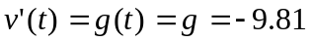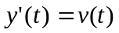

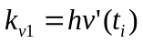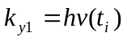

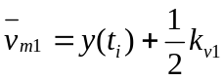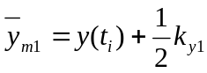

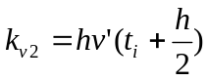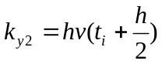

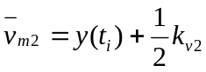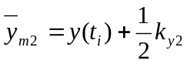

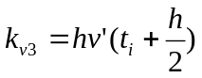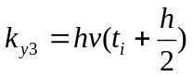

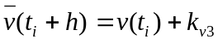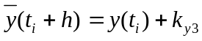

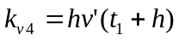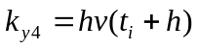

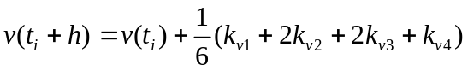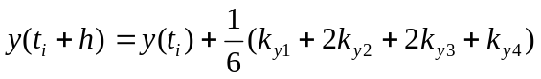

R-K Equations – Step # 2 Analysis

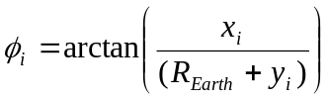

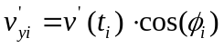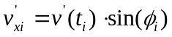

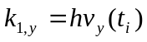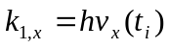
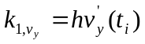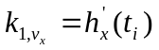
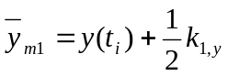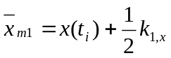
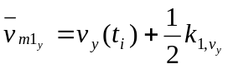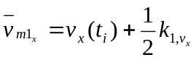
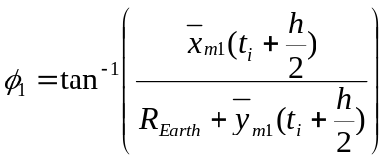
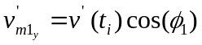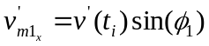

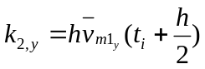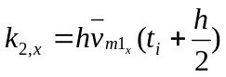
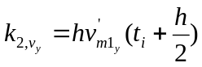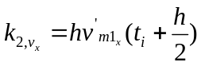
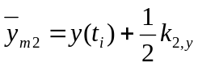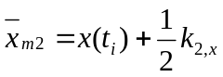
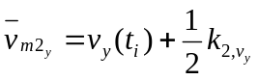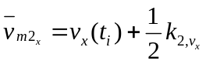
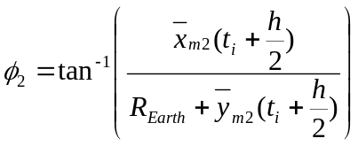
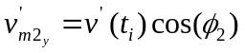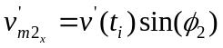

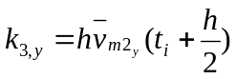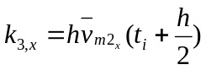
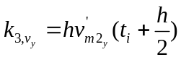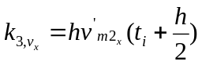
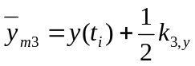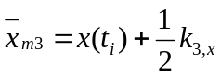
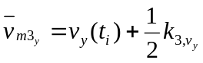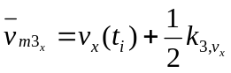
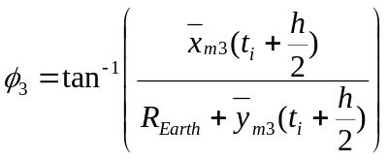
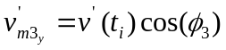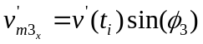

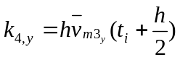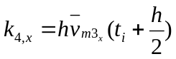
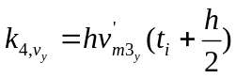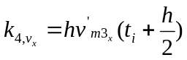
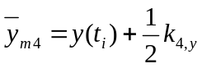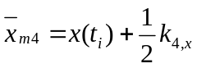
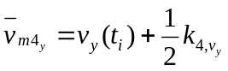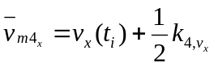
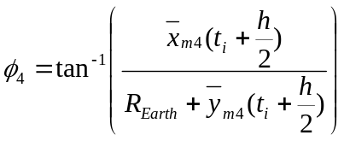
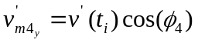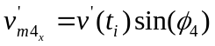

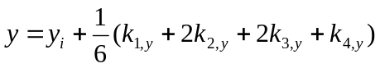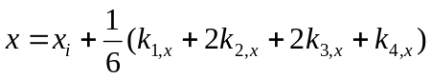
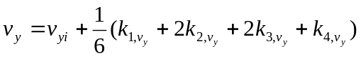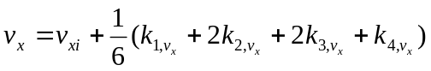

R-K Equations – Step # 3 Analysis

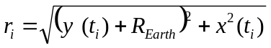

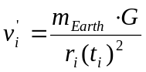

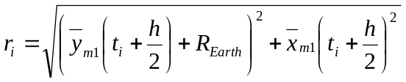
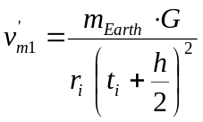

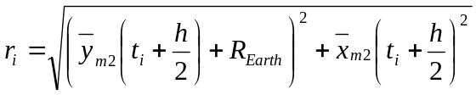
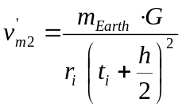

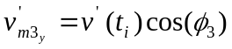
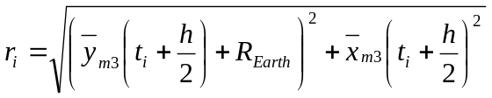
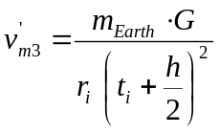

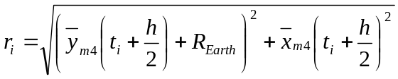
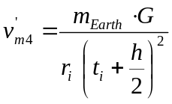

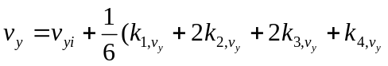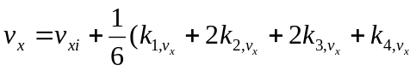

R-K Equations – Step # 4 Analysis

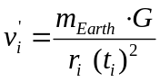

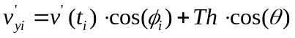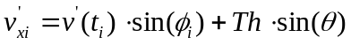

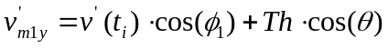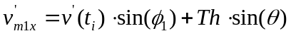

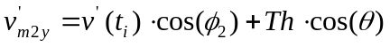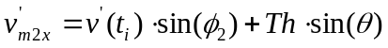

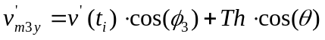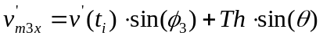

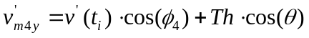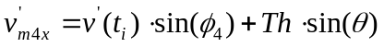

Appendix C - Graphs

Missile Trajectory for Analysis Step # 1

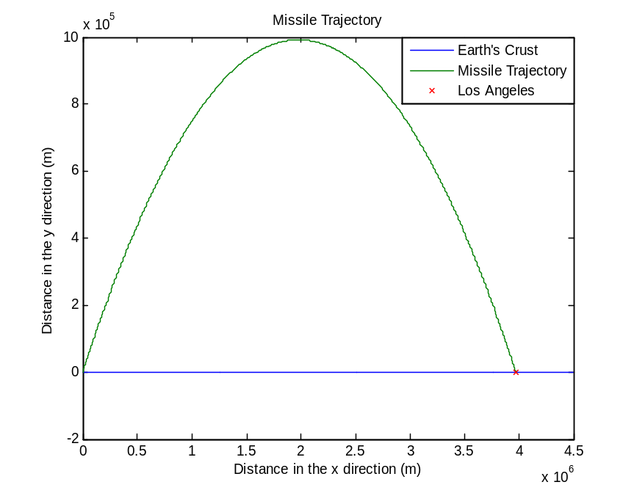

Missile Trajectory for Analysis Step # 2

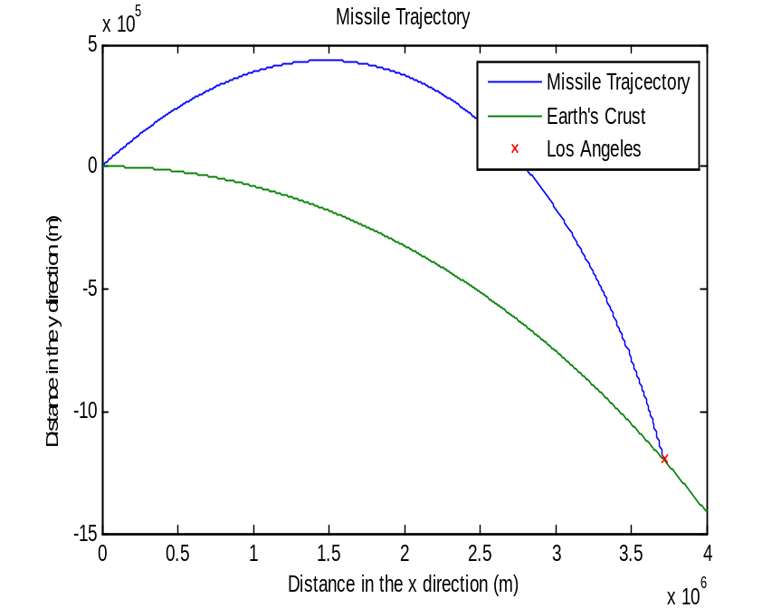

Missiles 1 & 2 in Analysis Step # 2 Environment

Missile Trajectory for Analysis Step # 3

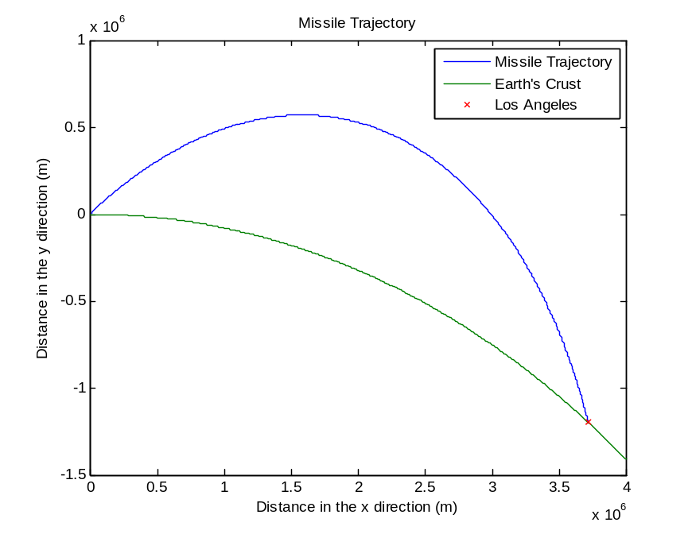

Missiles 1, 2, & 3 in Analysis Step # 3 Environment

Missile Trajectory for Analysis Step # 4

